City Buddy

Kshitij Sharma, Priyanka Kadam, Neerav Poriya, Tiffany Hatzidimitriu and Zo DiSanto

**Core tasks:**

 Traveling from location A to Location B (accessibility focused)

 Save trips and turn on alerts for delays and other updates on that route.

 Update the system with delays on the route with exact reasons (from the community to the community updates )

**Paper Prototype:**

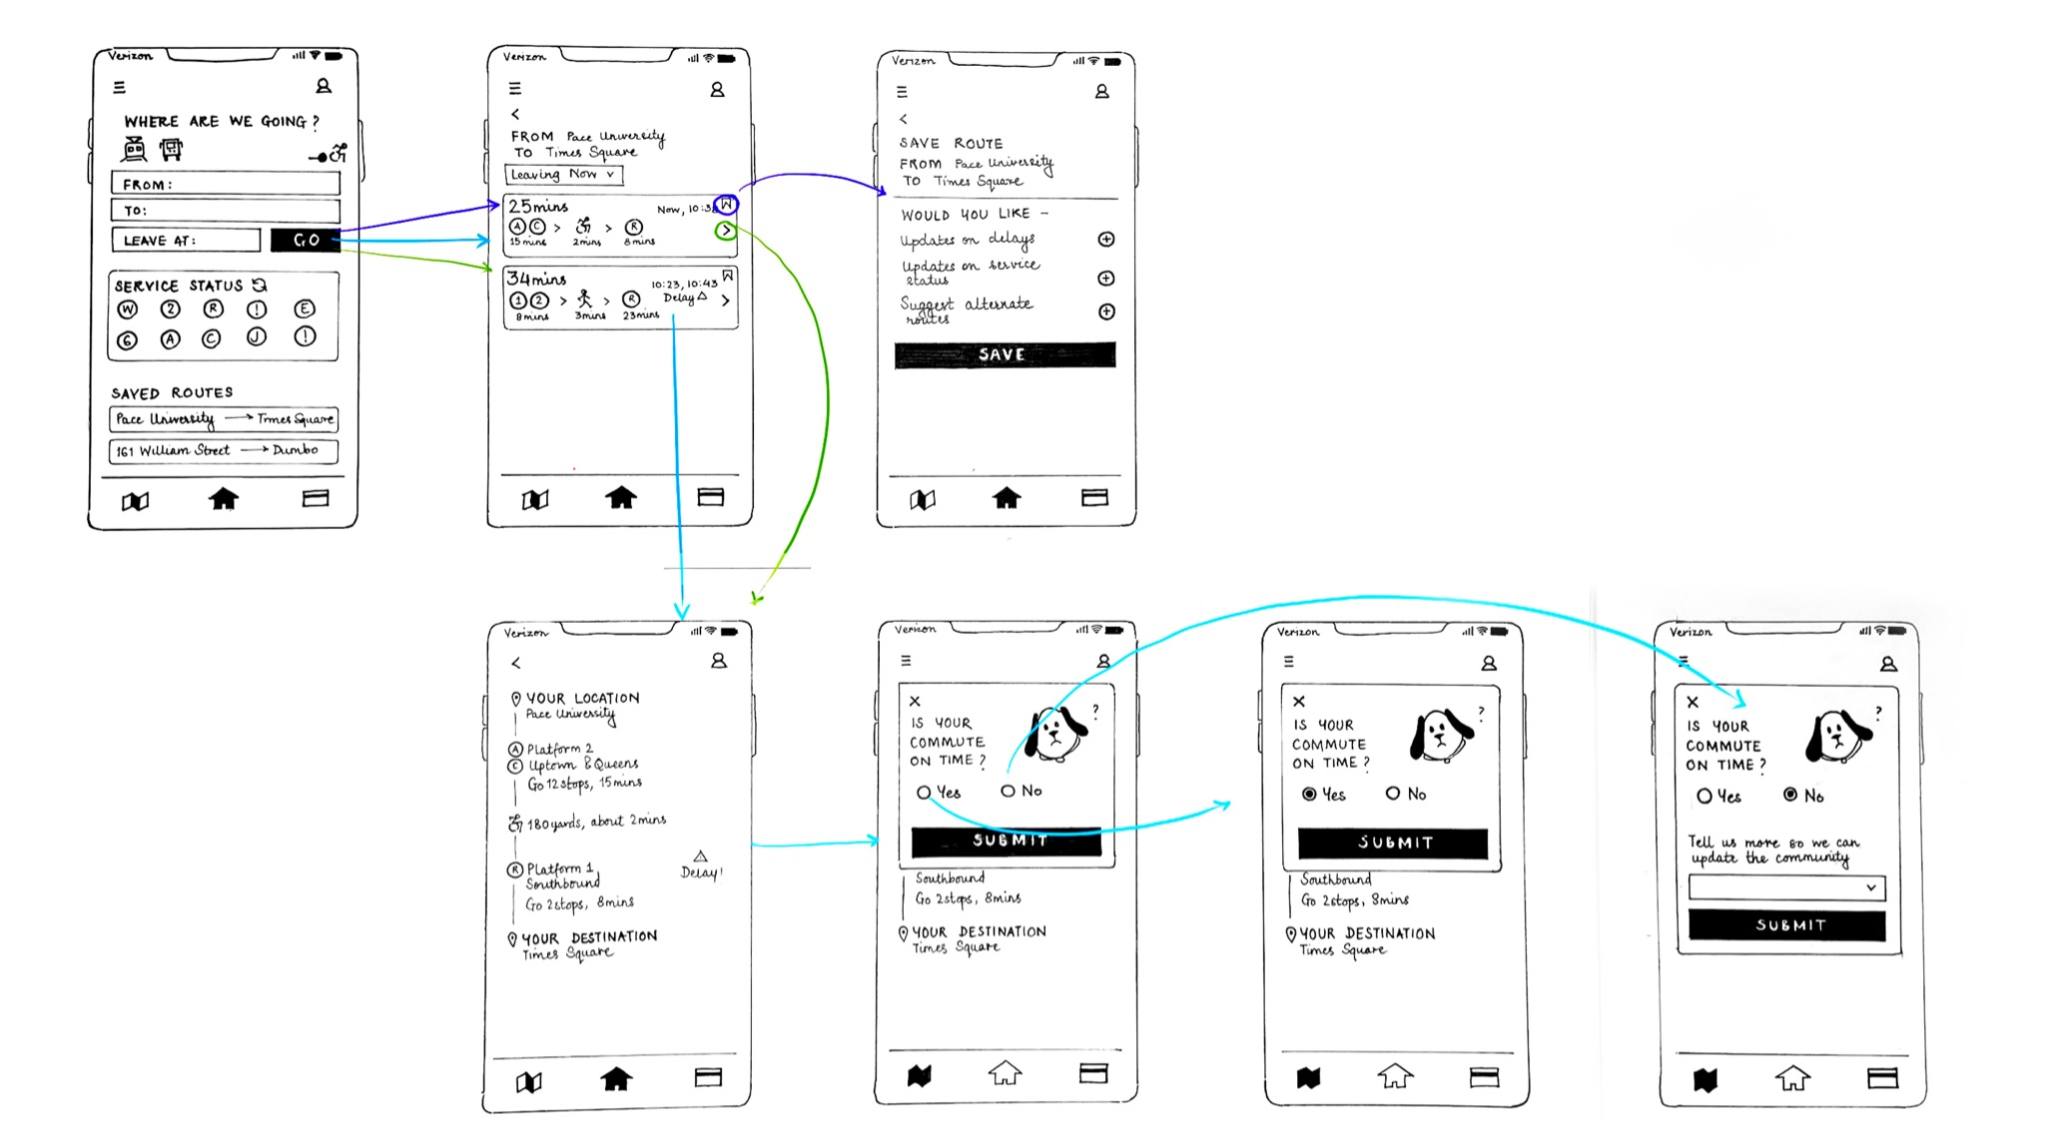

**Summary from testing:**

Throughout testing the paper wireframe on three different users, some of the features the users enjoyed included: the map, the notifications, the feedback features. Although our users didn’t need the accessibility feature, they noticed it and appreciated it. The service status was met with some confusion and it was recommended that service status should be in a list format and scrollable. The location of features received more criticism than the presence of the feature. While trying to make it clear to the users, afterwards, what our goal was, we were able to clear it up ourselves. We agreed on certain changes that our users did not point out, but we noticed as they were using the app as New York commuters.

**Changes we plan on making:**

* The location of the home button (put on the left not the center - important for habituation from other apps)
* The location of the service status should be below saved routes
  + Different metro card in metro card page & route options in map page. Cards besides metro card should be included, like senior card or student card
* More clickable train lines on the map feature
* Fonts and colors (though it was just a prototype) to guide the eye
  + Accessibility should be in color
* Marker / indicator to notify about new updates
* Change appearance of navigation bar when on selected page
* Did not realize travel type icons were buttons, round them out so they look like buttons
* “Where are we going?” box should be bigger
* Update / refresh button on service status should include previous update time

**Notes:**

### **User 1 Notes:**

* Starts with typing in To-From
* Clicked on navigation

#### *Likes:*

* + The map!
  + The metro card feature
  + Noticed the accessibility feature and appreciate it
  + Enjoys community based alerts

#### *Expectations:*

* + To see every route for one train, which is what we’re going for
  + Because all the streets can be confusing. Having every train line, when train line is pressed, highlights the single train line
  + Accessibility should be in profile
  + Service status should be listed with the updates, scrollable

#### *Dislikes:*

* + Can’t see toggle on for accessibility switch easily
  + Didn't notice saved routes right away (**maybe that should be above service status?**)
  + Change fonts - bigger and more color
    - Black and white AND primaries? (mondrian)

### 

### **User 2 Notes:**

#### *Likes:*

* + Likes the notification on alert.
  + Really enjoy the feedback.
    - Makes the user feel appreciated
  + Likes the map
  + Even if not actively commuting, like the updates
  + Saved routes are clear and Likes the Feature!
    - More Saved Routes above Service Status

#### *Expectations:*

* + Thinks alert is for after commuting.
  + Home on the left not the center
    - Important for habituation from other apps
  + Want to see other route options shown in different color
    - Want to see whole map, not just the route that's been selected
  + Wants it to (payment method) work on apple watch
  + Card history needs to be better explained (perhaps just a title)
  + Not sure what to expect from top left menu bar
    - Significant news or disruptions?
    - My profile in profile and community updates in top left menu bar
  + “Refresh” written on refresh button

#### *Dislikes:*

* + Cannot tell which screen they are on
    - Bottom nav bar should indicate what page you're on
  + Would like an explanation for the Alert
    - Initial explanation of certain buttons when you first sign up.
  + Didn't see selection for type of transport
    - Perhaps have two options on whether or not the user wants to bike/walk/subway/taxi or car… users sometimes change their mind.
  + Unclear on community based nav alerts
    - Overcrowded and It's Friday kinda the same, has some concussion there
  + Doesn’t know what Service Status means (Reword)
  + Accessibility toggle should be different color, unclear that its a button
    - Should the nav filters like accessibility be bigger

### **User 3 Notes:**

#### *Likes:*

* + Likes the maps
  + Notifications of delays are really interesting. Would definitely use an app with that feature
  + Straightforward and intuitive

#### *Expectations:*

* + Notifications only for selected routes
  + Wants Long Island Railroad included
  + Needs a marker to notify about new updates on the menu

#### *Dislikes:*

* + Didn’t know what to expect in the hamburger menu
  + Difficult to figure which screen is open
  + Didn’t notice the refresh button
  + Doesn’t know what Service Status means (Reword)